NEXT YEAR’S BOOKS 2019-2020
Terminale OIB Language and Literature
New Cambridge University Press Penguin Classics Faber and Faber
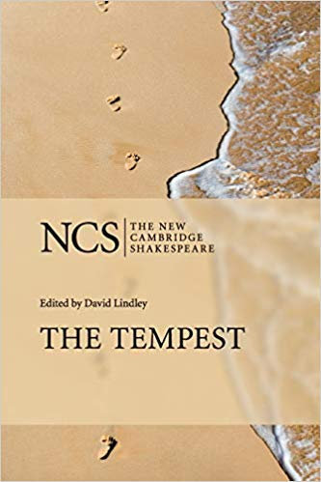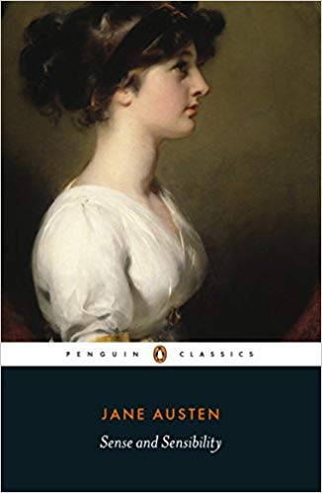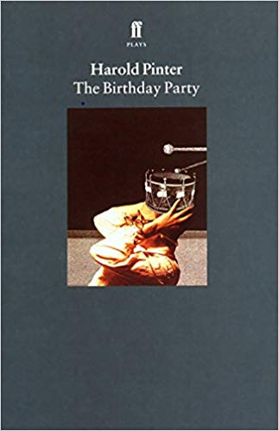
The Tempest, Shakespeare (New Cambridge University Press)
Sense and Sensibility, Jane Austen (Penguin Classics)
The Birthday Party, Harold Pinter (Faber and Faber)
Première OIB Language and Literature
Penguin Classics Penguin Modern Classics Picador

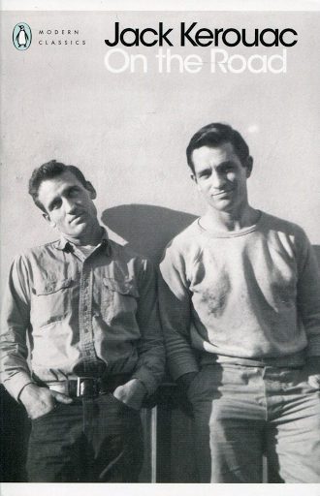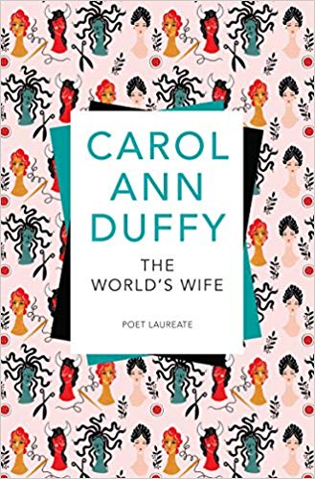
Sense and Sensibility, Jane Austen (edition Penguin Classics)
On The Road, Jack Kerouac (edition Penguin Modern Classics)
The Word’s Wife, Carol Ann Duffy (edition Picador)

